**K-Means Clustering:**

Why Clustering?

Starbucks customers have various attributes related to them --and clustering allows for us to group them together by similarities to create a stronger and more targeted approach for our marketing efforts

What is Clustering?

Groups objects (customers) together based on some kind of similarity. Similar objects are grouped together and those that are different (farther apart) will be put in a separate cluster. Each customer will only grouped in one cluster.

Elbow Plot:

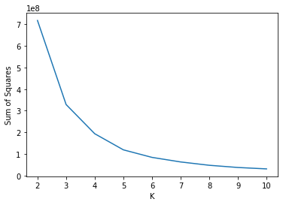 

Distribution Plots (with standardization):

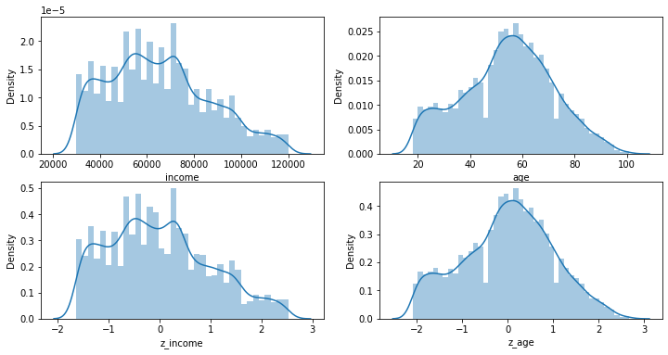

Distribution of Income:

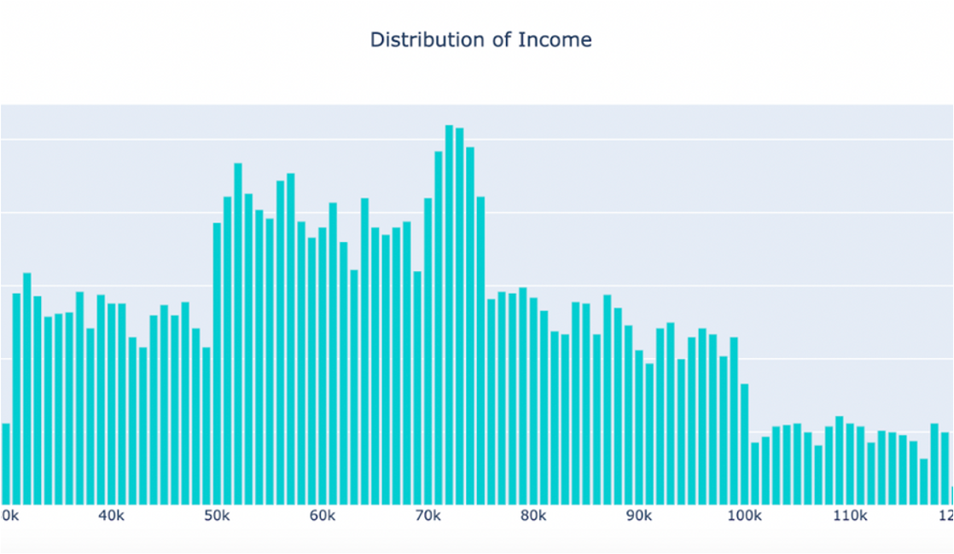

Distribution of Age:

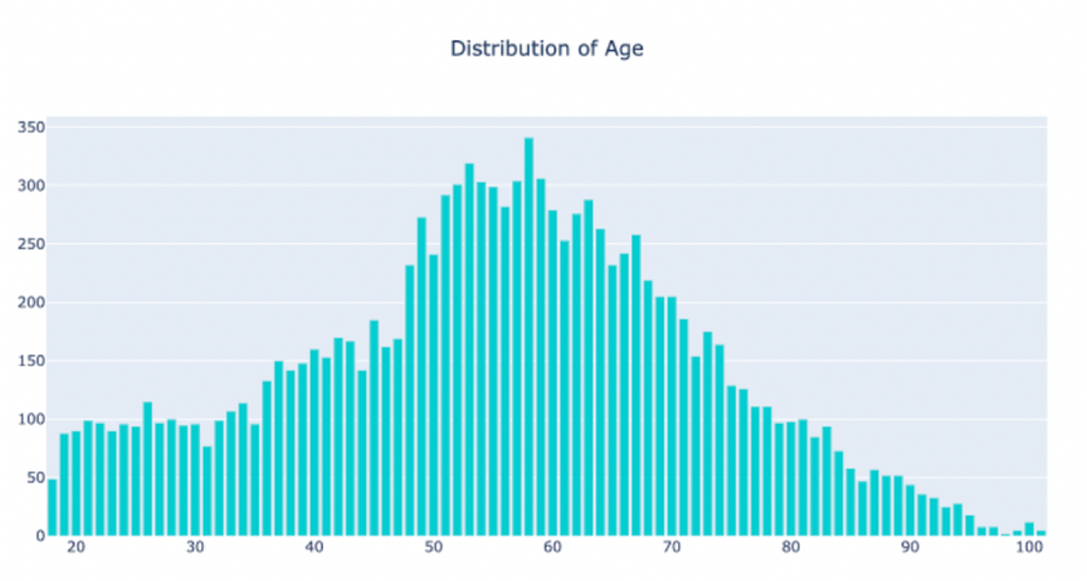

Distribution of Age:

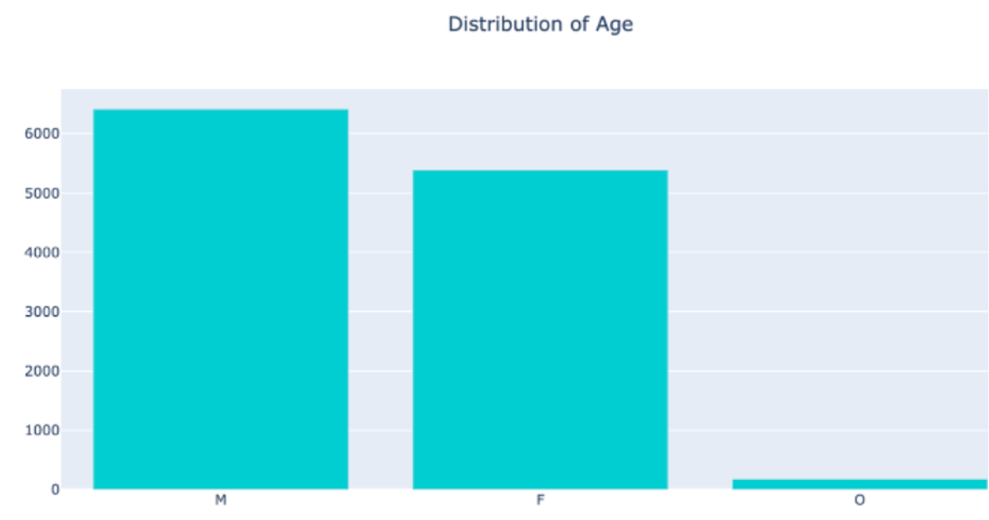

Clustering Scatterplo



